**EC AUTOMATION SETUP**

**ON TCSS FRAMEWORK BKM**

|  |  |  |  |
| --- | --- | --- | --- |
| Date | Author | Revision | Remarks |
| 11 Nov 2018 | Lalatendu Satpathy | Initial Draft |  |
| 7 December 2018 | Lalatendu Satpathy | Added Eclipse settings details |  |
| 10th December 2018 | Amit Kumar Panigrahi  Lalatendu Satpathy | Added local shared location and other installation details. |  |
| December 31, 2018 | Amit Kumar Panigrahi  Lalatendu Satpathy | Updated with more Screenshots of installations |  |

Contents

**Hardware Requirements:** 3

**Functionalities of TTK & Relay** 3

**Rework required for TTK & Relay** 3

**Connection for TTK & Relay** 4

**TTK Front panel header and SPI connections** 4

**GPIO Relay connection** 5

**Hardware Reworks** 5

**Battery Connection to GPIOs** 5

**Post Code Reader Connection.** 7

**SML Card Connection** 7

**TTK 2 Installation** 7

**Steps for TTK Installation:** 7

**TTK APIs and Example Code** 8

**TTK GUI** 8

**Hardware Setup:** 10

**Pre Requirement:** 11

**Software requirements:** 11

**Setup Repos** 11

**Setup SUT** 11

**Setup Host** 14

**NRS Board Setup:** 19

**HW (DUT) Config file for project:** 20

**Device Config file** 20

**How to Run Test** 20

**Run a Single Test** 22

**Modules to be used for write a new test scripts** 22

**Troubleshoot** 23

**Summary**

This BKM is to setup the host and DUT/SUT for Automation of TCSS Framework.

**Hardware Requirements:**

* **HOST Machine**
* **SUT** 
  + Ex. Intel Platforms ICL, KBL, etc.
* **NRS Switch Board with switches**
  + To control connect and disconnect of TypeC devices (USB drives, Thunderbolt device, TypeC Chargers, TypeC displays, etc.)
* **Display Sensors**
  + <http://www.yoctopuce.com/EN/products/usb-environmental-sensors/yocto-light-v3>
* **TTK** **[Touch less Tool Kit]**

TTK device is connected to USB port of the host machine & another end of TTK is connected to SUT through the 8 port relay where the hardware functionalities of the test cases are taken care by ttk through HOST machine python or C# Test Scripts.

* Post code reader Card (GLIDER Card)
* SML Card for reading Sx LED status monitoring

# **Functionalities of TTK & Relay**

* Power Cycling Control
* Front Panel Power On/Off Control & RESET
* Real time postcode, voltages & LEDs Monitoring
* BIOS Programming (Single/Parallel Multiple BIOS Burning)
* Jumper Settings (GPIO)
* Battery connect and disconnect using GPIO switching.
* Hardware button press (Power, Reset, Volume UP and Volume DOWN )

# **Rework required for TTK & Relay**

* Power cable has to be cut and put in to this relay card.
* Other side the connection should be from TTK

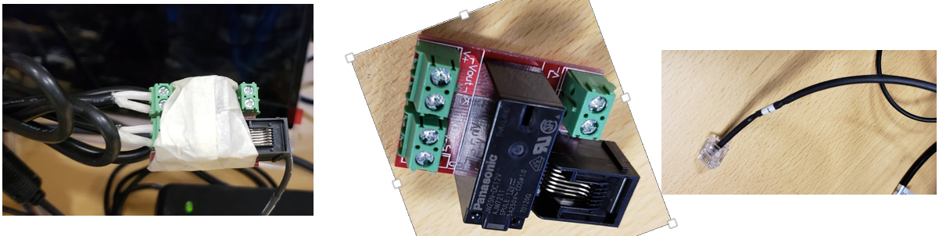

# **Connection for TTK & Relay**

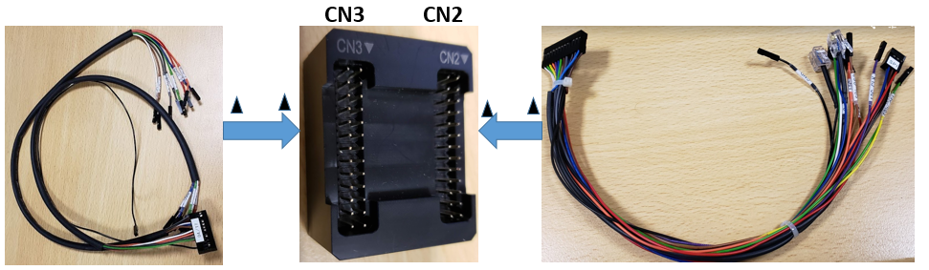

# **TTK Front panel header and SPI connections**

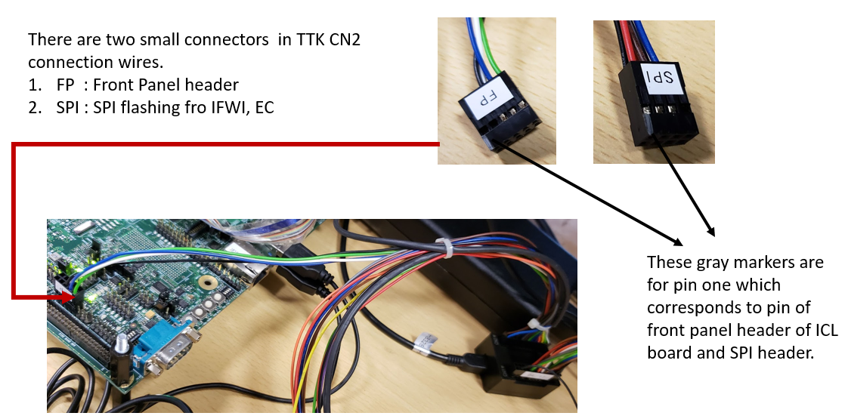

# **GPIO Relay connection**

TTK Supports 8 GPIO pins and connections to the Inverter cards 10 pin connector as below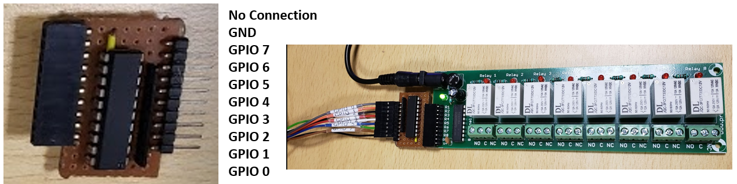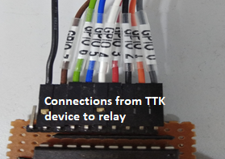

# **Hardware Reworks**

* Battery Connector

TO DO

* Glider Card for Postcode reader

TO DO

# **Battery Connection to GPIOs**

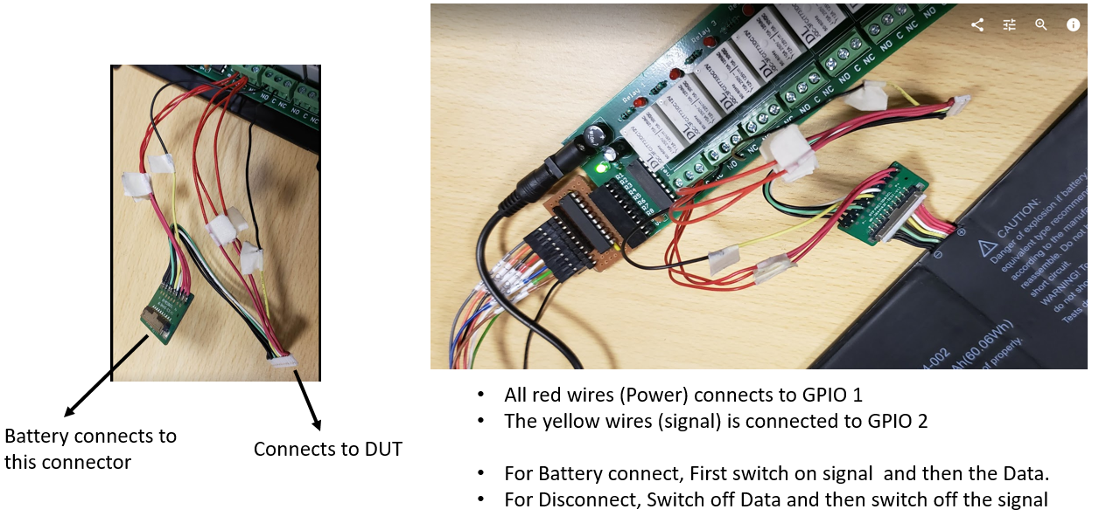

* Battery connect Disconnect can be tested

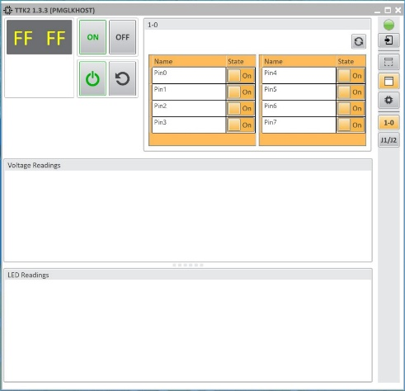

* All red wires (Power) connects to GPIO 1
* The yellow wires (signal) is connected to GPIO 2
* For Battery connect,
  + Switch on GPIO 2 (signal)
  + Switch on GPIO 1 (power)
  + Check DUT booting with battery.
  + DUT can be switch on through A/C and can be checked if battery is charging.
* For Disconnect,
  + Switch of A/C power
  + Switch off GPIO 1 (Power)
  + Switch off GPIO 2 (Signal)
  + DUT should shutdown.
* Battery power connects to GPIO 1
* Battery signal is connected to GPIO 2
* Power button connects to GPIO 7
* Reset button connects to GPIO 8

Steps for

* AC Connect
  + Switch on the Power control
  + Press the Power button switch on the Power - GPI0 7 ON –OFF
  + Delay 2 sec
* AC Disconnect
  + Shutdown
  + Switch off the Power control
* Only Battery connect
  + Battery signal GPIO ON
  + Battery Power GPIO ON
  + Press the Power button switch on the Power - GPI0 7 ON –OFF
* only Battery Disconnect
  + Shutdown
  + Battery Power GPIO OFF
  + Battery signal GPIO OFF
* Battery connect and AC connect
  + Battery signal GPIO ON
  + Battery Power GPIO ON
  + Press the Power button switch on the Power - GPI0 7 ON –OFF
  + Switch on the Power control
  + Press the Power button switch on the Power - GPI0 7 ON –OFF
* Delay 2 sec

# **Post Code Reader Connection.**

GND SDA SCL

GND I2C I2C CLK

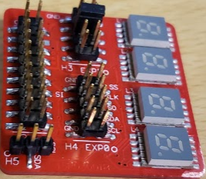

From TTK

# **SML Card Connection**

**TO DO**

# **TTK 2 Installation**

* Make sure windows update is disabled.
* Installer is available at \\akasha1\EC_Validation\EC_TCSS_Automation\EC_Automation_TCSSFW\install_ttk2
  + Install install_ttk2\Python.net_python27-2.0.18.win-amd64.exe
  + Install install_ttk2\pyreadline-2.0.1.win-amd64.msi
  + Install install_ttk2\TTK2_133.msi
* The default location it will install in to is c:\SVShare\user_apps\TTK2\

# **Steps for TTK Installation:**

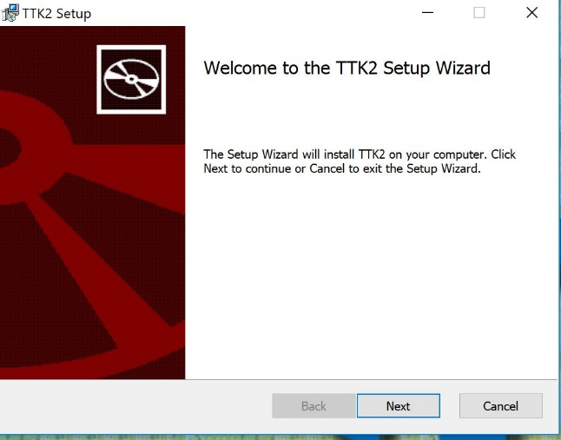 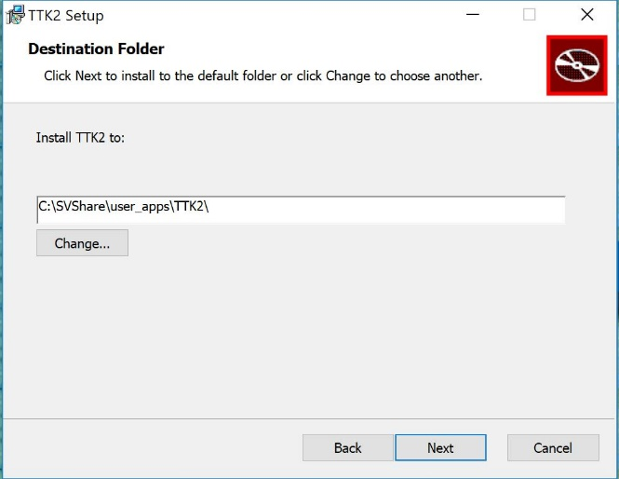

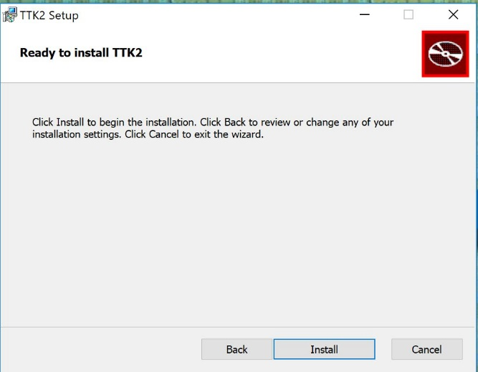 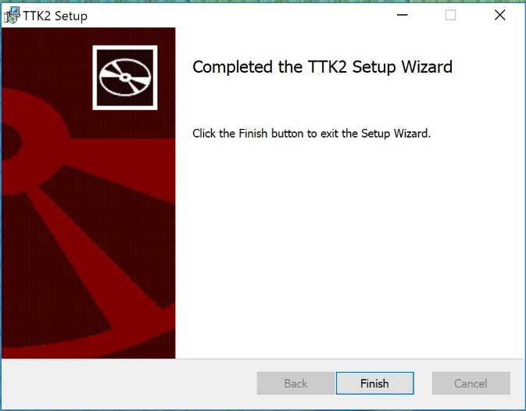

# **TTK APIs and Example Code**

TTK APIs ad Example codes are available in C:\SVShare\user_apps\TTK2 folder.

TTK Can be tested first using the TTK Example APIs by going to Examples folder and running those python.

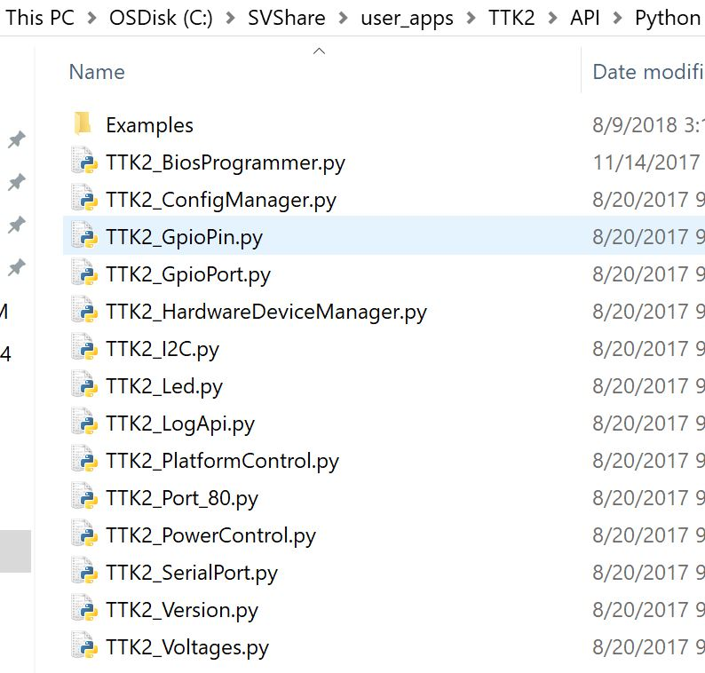 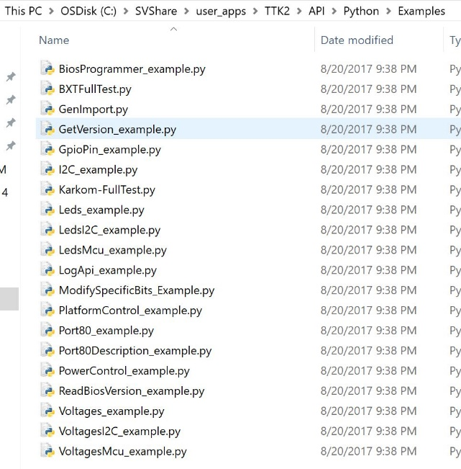

# **TTK GUI**

After running TTK2 desktop app, if only one TTK device is connected it will show the default device, Power Control as ThumbKing and Platform as MiniPort80_smbus.

It will show up with Lite view.

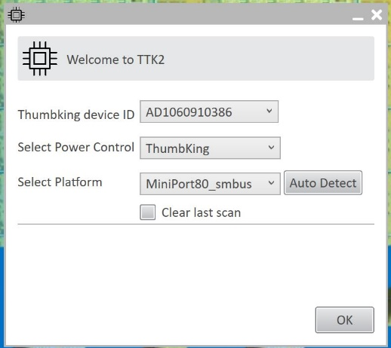 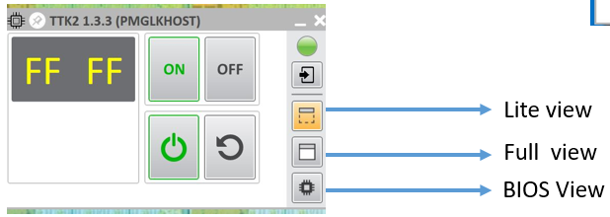

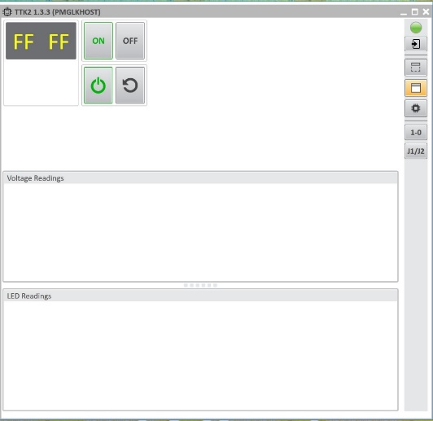 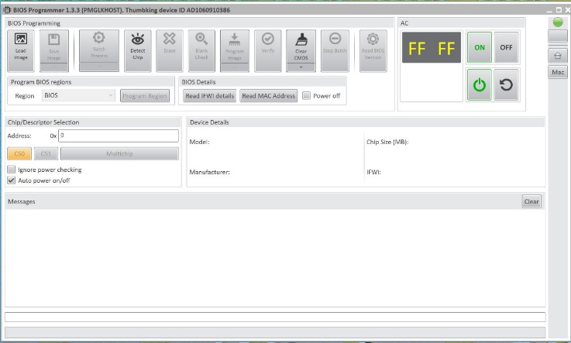

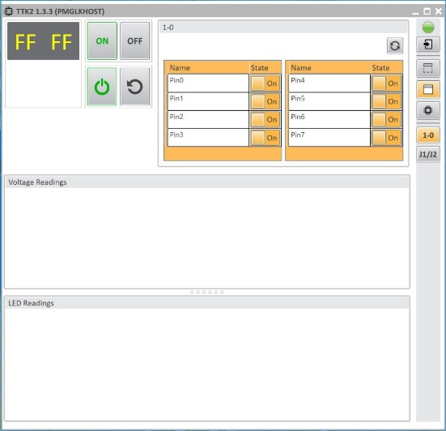

* Switch ON/OFF the GPIO to see if the lights on the relay goes on/off.
* Postcode can be read if the I2C lines are connected to the postcode reader.
* Board switch ON/OFF (G3) can be done using the GUI buttons.

# **Hardware Setup:**

* Connect the SUT and host via USB-Ethernet connection

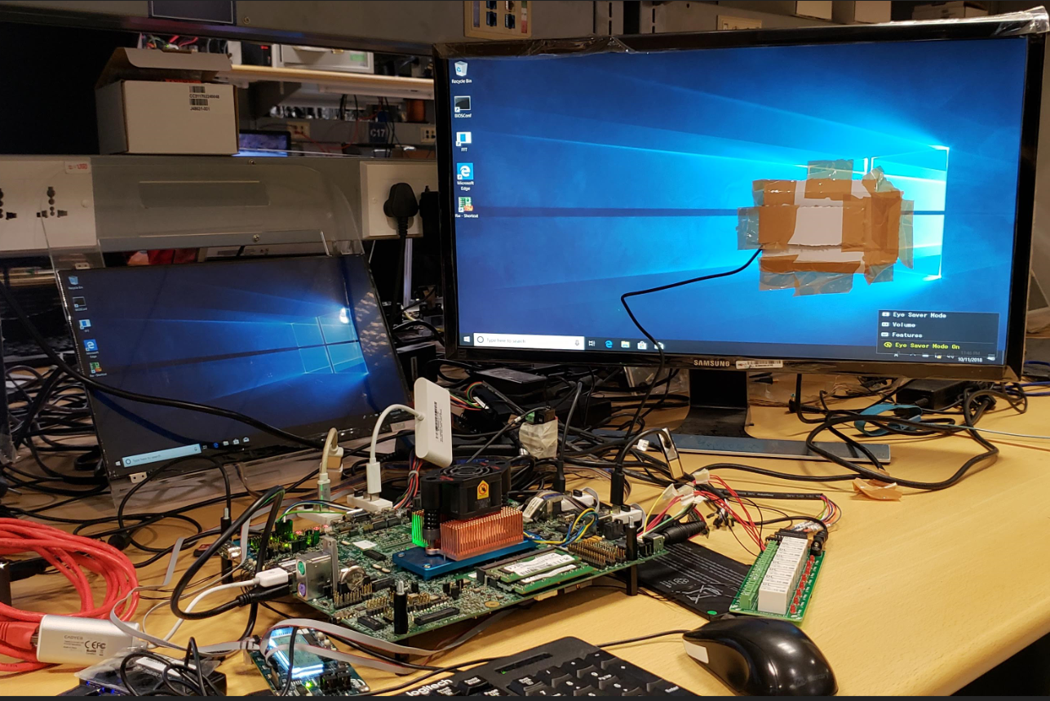

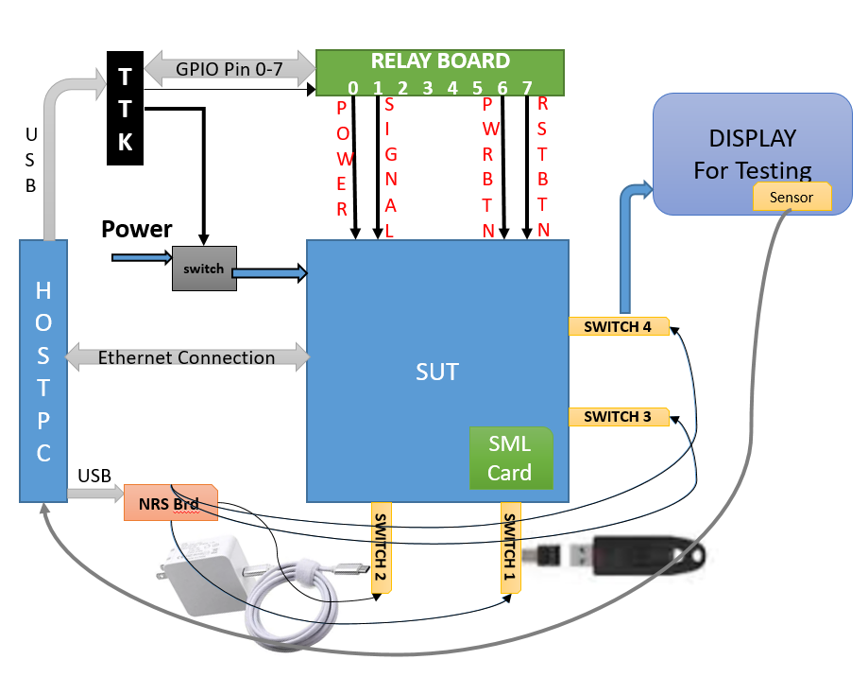

# **Pre Requirement:**

* Use latest config for intial setup the SUT.(BKC,BIOS/EC/FW etc)
* Enable XMLCLI in Bios.
* Do all necessary rework on board (Gpios, power button, reset button, lid switch etc.)
* Connect TTK H/W and necessary GPIOs connection for battery, power button, etc. to the relay.
* Hardware rework for Glider Card (for POST Code reader)

# **Software requirements:**

All required setup files are available in \\akasha1\EC_Validation\EC_TCSS_Automation\EC_Automation_TCSSFW\

* Setup folder
* WMI.exe
* Intel® CCG Platform Tools SDK
* Intel FFT - Intel FFT 1.0.146.zip

# **Setup Repos**

* Clone "[Automation](https://tf-amr-1.devtools.intel.com/sf/scm/do/viewRepositorySource/projects.pipd_sse/scm.Automation)" and "[Automation Library](https://tf-amr-1.devtools.intel.com/sf/scm/do/viewRepositorySource/projects.pipd_sse/scm.Automation_Library)" repos from here: <https://tf-amr-1.devtools.intel.com/sf/projects/pipd_sse/> (Currently automation folder taken from the \\akasha1\EC_Validation\EC_TCSS_Automation ,need access to repo..)
* Checkout the master branch of both repos.
* Copy pipd_sse-automation_libs and pipd_sse-automation repos to the DUT at the same exact location as you Host/Development system.
* For example, if the repos are located at c:\repos\ on the Host, then they must be at this same location on the DUT.

# **Setup SUT**

* Download setup package from \\akasha1\EC_Validation\EC_TCSS_Automation
* Create the directory c:\Imaging on the DUT.
* Copy the contents of setup folder on DUT in the directory c:\Imaging.
* Open command prompt as admin and cd to c:\Imaging directory.
* Execute script dut_setup.bat. Do not interact with system until setup completes.
* Reboot DUT.
* Rename the DUT name.
  + Right-click on the Start button and click Control Panel. 2. Navigate to System and either click Advanced system settings in the left-hand menu or click **Change** settings under **Computer name**, domain, and workgroup settings. This will open the System Properties window.
  + After rename the DUt perform a reboot.
* Mac Address
  + Get the Mac address of the Board which is written on the Board.
  + Unzip and Install Intel FFT 1.0.146.zip
  + Run fft application, and run the below command.
    - fft.exe flashmac:9040XXXXXXX
* Run set_python_reg.py
  + 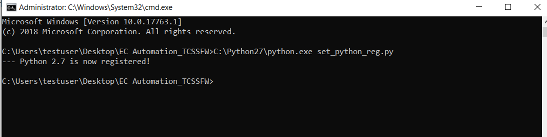
* Install WMI.exe

After installing confirm if all packages are working.

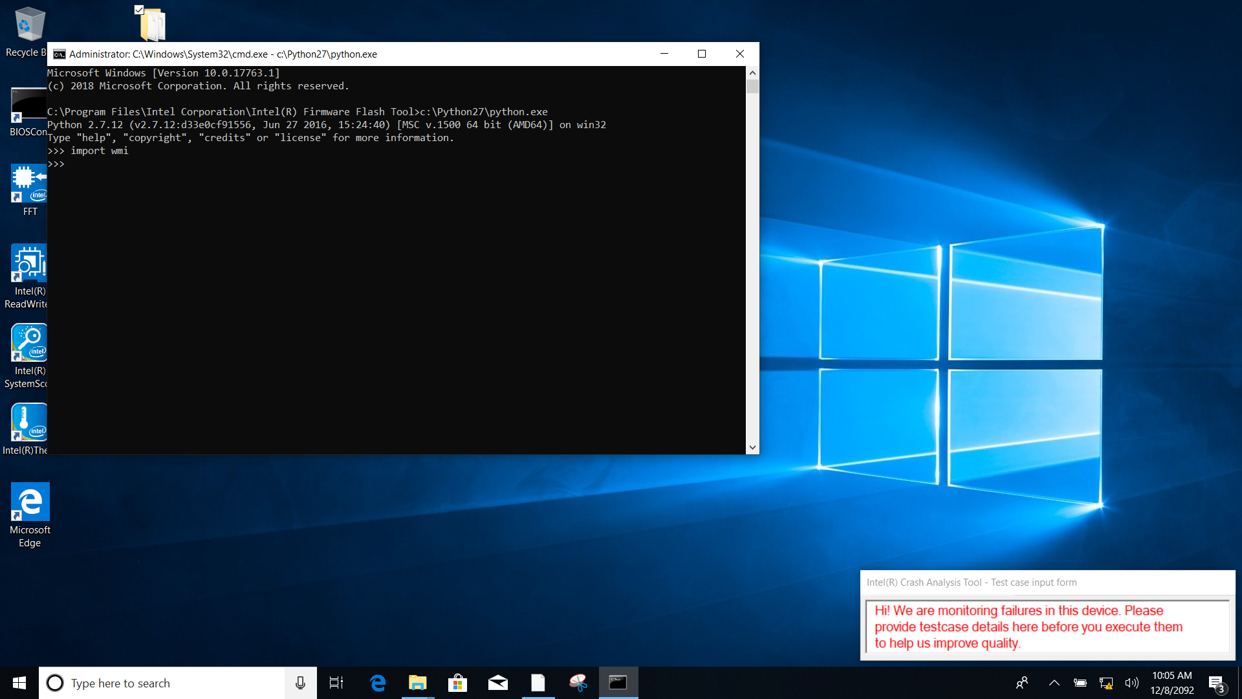

* In SUT : In Task Scheduler, go to RYPC properties, In Condition tab, uncheck the box “Start the Task only if the computer is on AC power” When prompting for password give intel123

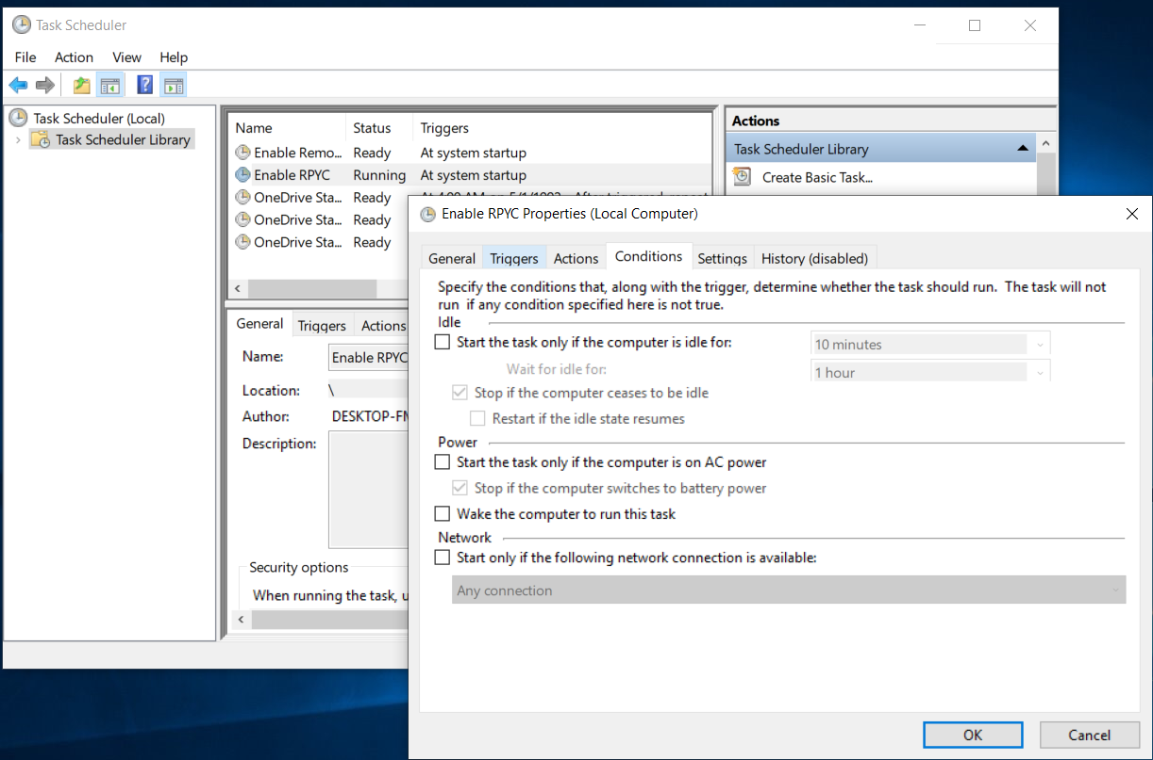

* Install xmlcli SDK. (Run setup file from Intel® CCG Platform Tools SDK)
* Copy the Sourcecode (Automation folder) to C:\Automation
* Copy Xmlcli tools to C:\Automation\tools folder

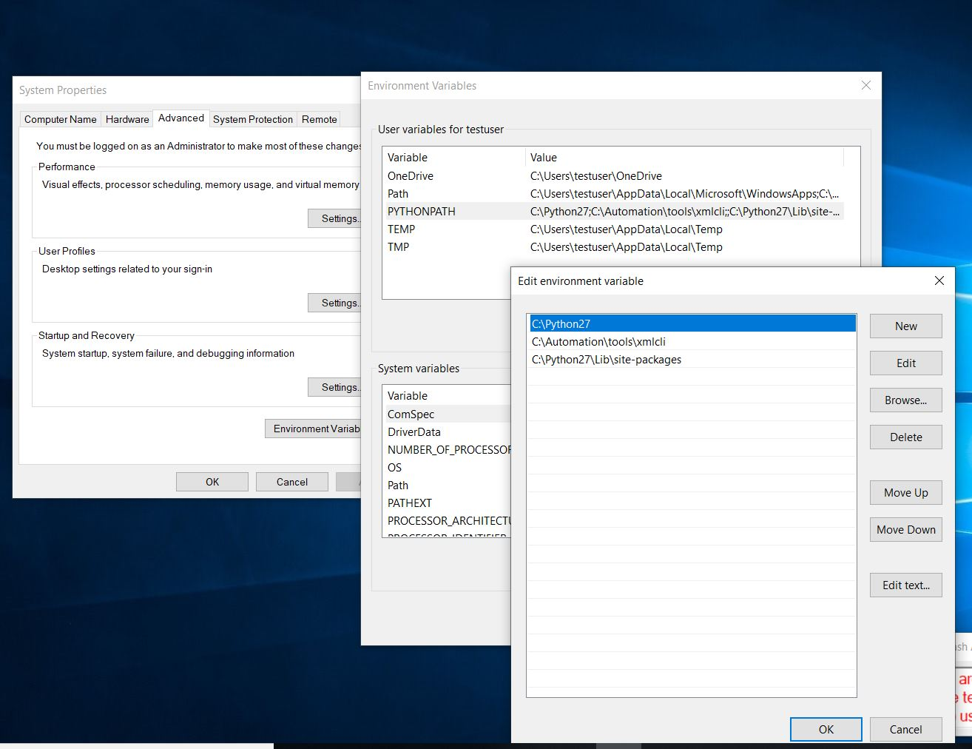

* Copy the ifwi binary to C:\Automation\tools\xmlcli\out in SUT
* Modify the current used IFWI binary name in pipd_sse-automation\test_steps\common\setup\lib_set_bios.py(Line number 122,)
* copy files from C:\Imaging\usbc_tools\exe to pipd_sse-automation\test_steps\usb_c\exe
* Copy files from c:\Imaging\tools to pipd_sse-automation_libs\tools
* Reboot the DUT.

# **Setup Host**

* Press the Windows logo key + R then type gpedit.msc and click OK. Go to Computer Configuration > Administrative Templates > WindowsComponents > Windows Update. Select Disabled in Configured Automatic Updates on the left, and click Apply and OK to disable the Windows automatic update feature.

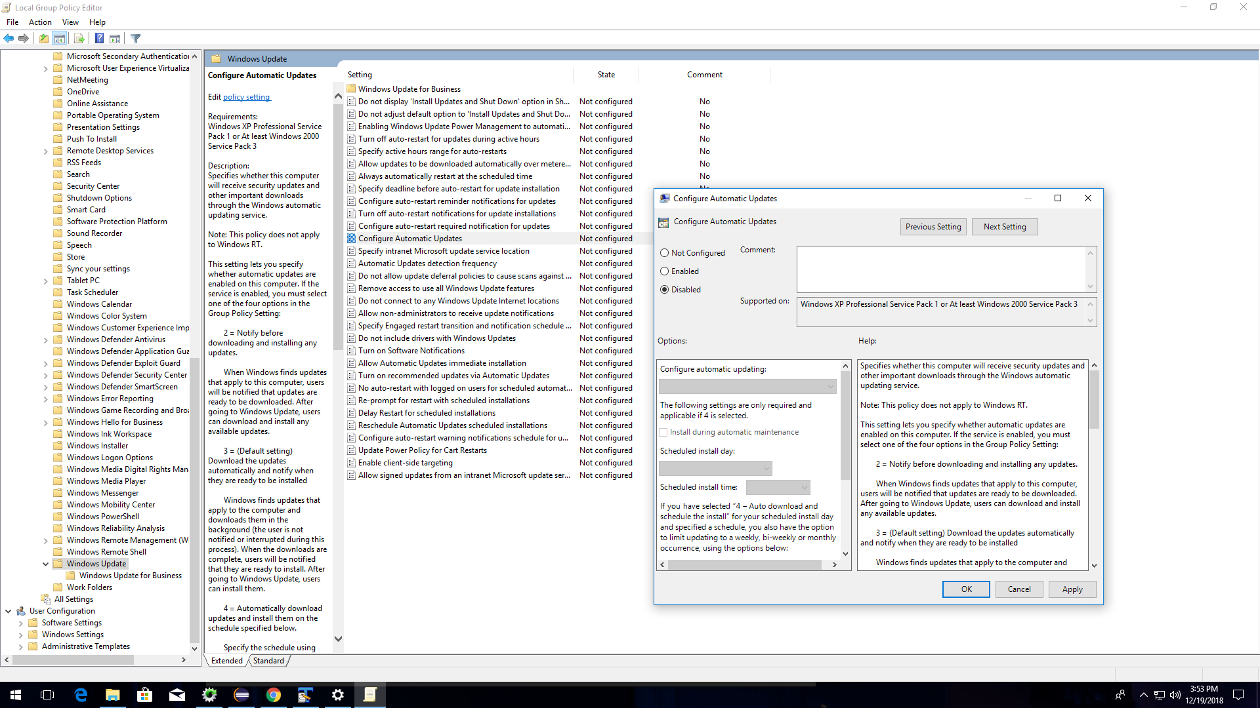

* If TTK is already installed then uninstall and reinstall gain.
* Download setup package - \\ilabfm73r7h11\jenkins\teamciy_setup\setup.zip
* Create the directory c:\Imaging on the Host
* Unzip package to Host in the directory c:\Imaging.
* Uninstall the existing python installer.
* Open command prompt as admin and cd to package directory.
* Execute script install_pytthon.bat
* Copy Automation folder from repo. (currently from \\akasha1\EC_Validation\EC_TCSS_Automation )
* LED Connection in SML Card should be changed in get_led_status function
* Copy Xmlcli tools to C:\Automation\tools folder
* Reboot the Host Machine.
* Run WinRM quickconfig on command prompt (In progress to check)
* On the Host/Development system, run the script pipd_sse-automation_libs/setup/rpyc/setup.bat
* Install pywin32 module

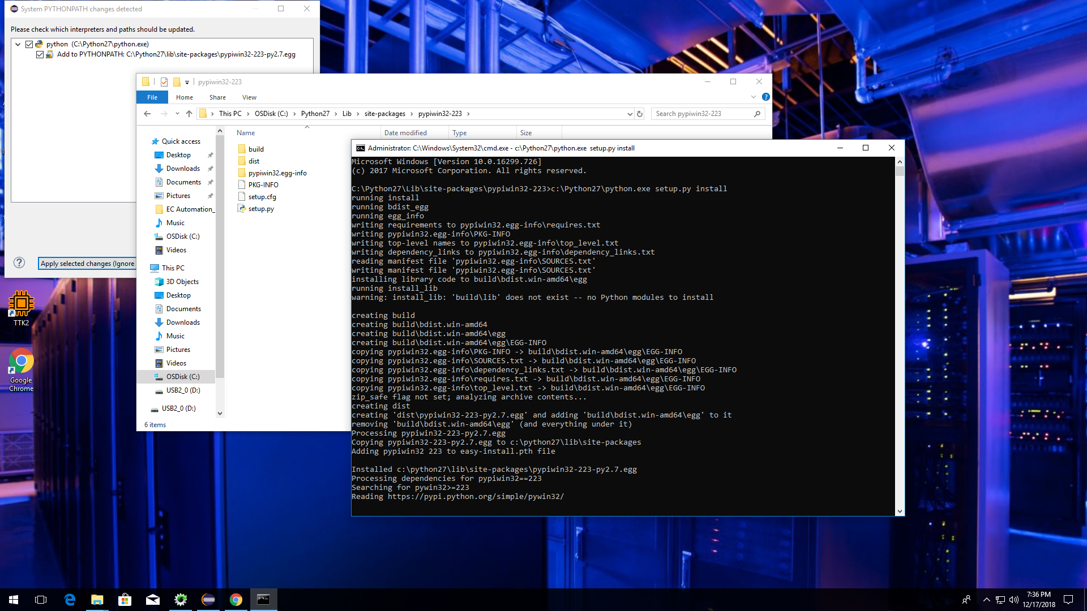

* Before install eclipse install Java.(Example:JDK-8u191-windows-x64.exe)
* Configure “Network proxy settings”, Go to windows network proxy settings and give manual Address : <http://proxy-iind.intel.com> and port : 912

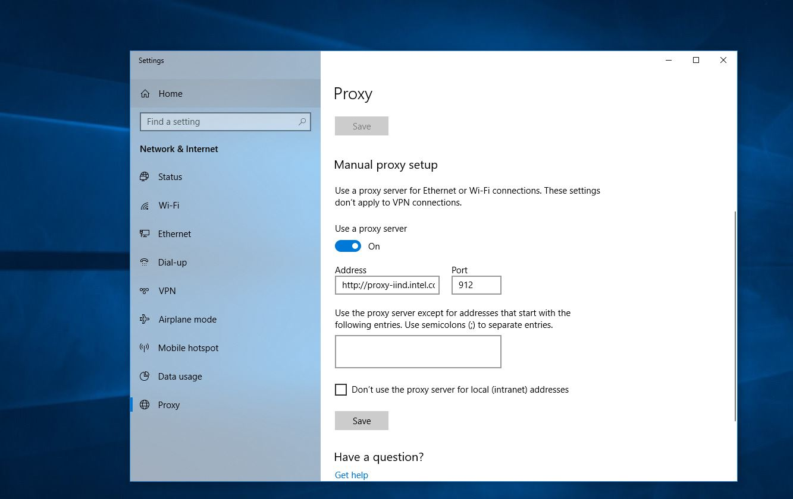

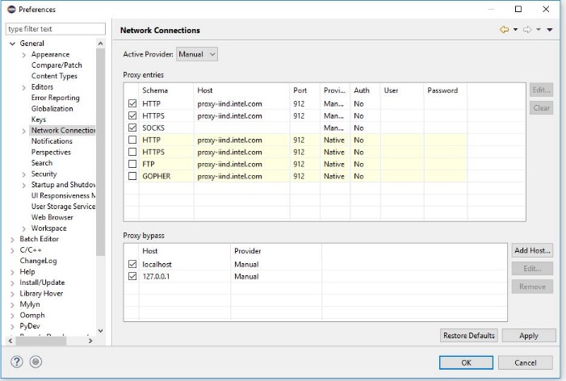

* Install eclipse
  + Eclipse IDE for Java Developers
  + From Help- Eclipse Market place, Install Pydev and Batch editor
  + How to Setup Python
    - Open Eclipse and Go to Windows->Preferences->PyDev->Interpreters->Python Interpreters
    - Select "Browse for Python..." and Browse to c:\python27 and select python.exe
    - Click ok and wait for modules to be imported.

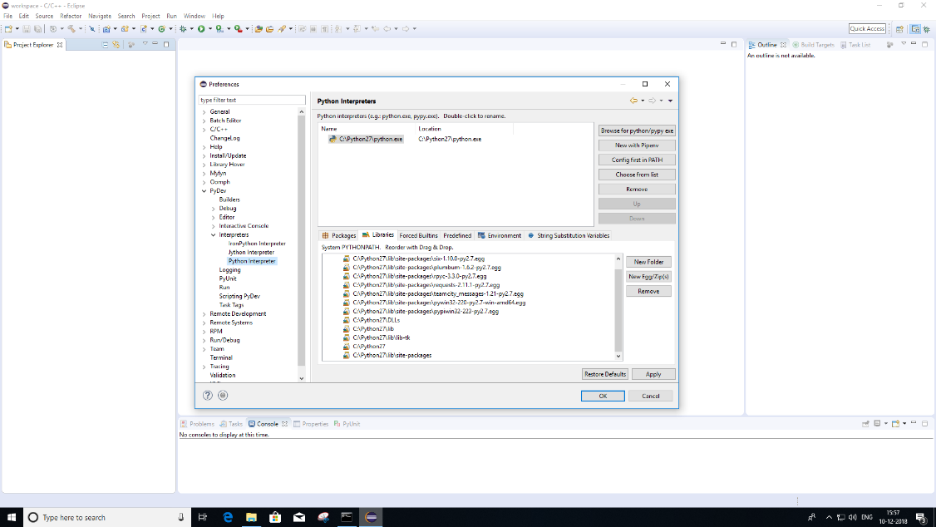

* + Importing projects
    - File – Import projects
    - Click General - > Existing projects to workspace.

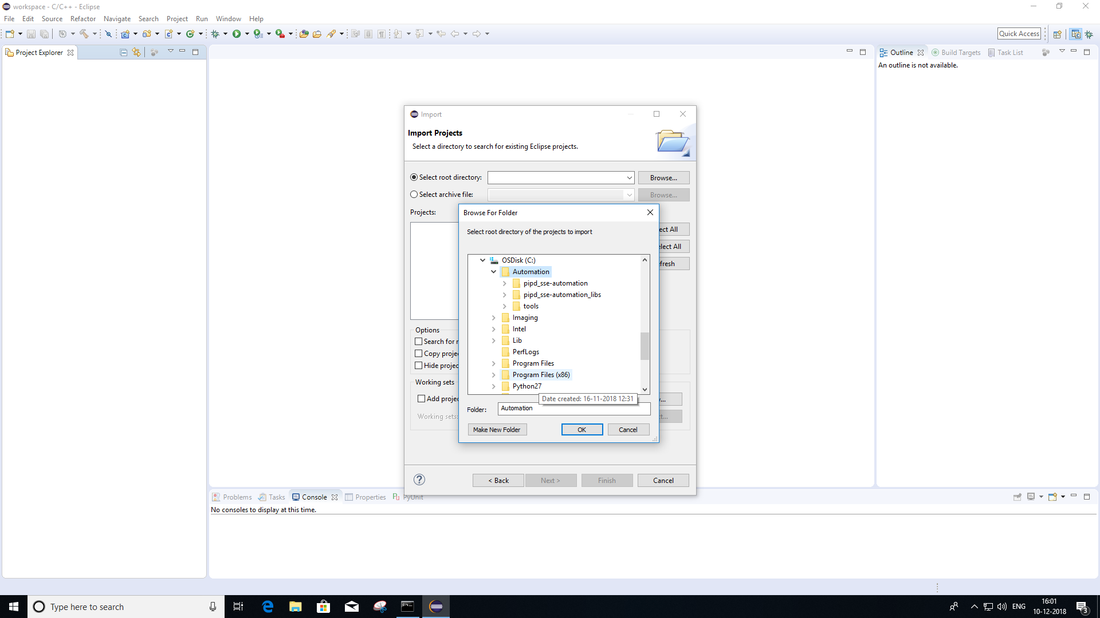

* + - Browse to automation folder where the code is available.

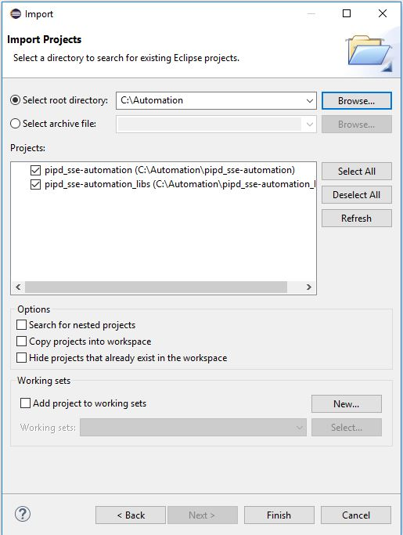

* + External hardware(ttk/sensor) Libraries
    - In eclipse select project->properties->pydev-PYTHONPATH
    - Go to external libraries tab
    - Click add source to folder
      * Browse to c:\SSVshare\user_apps\TTK2
      * Browse to c:\SSVshare\user_apps\TTK2\API\Python
      * Browse to c:\imaging\python\yoctoLib_python\Sources (for display sensor)

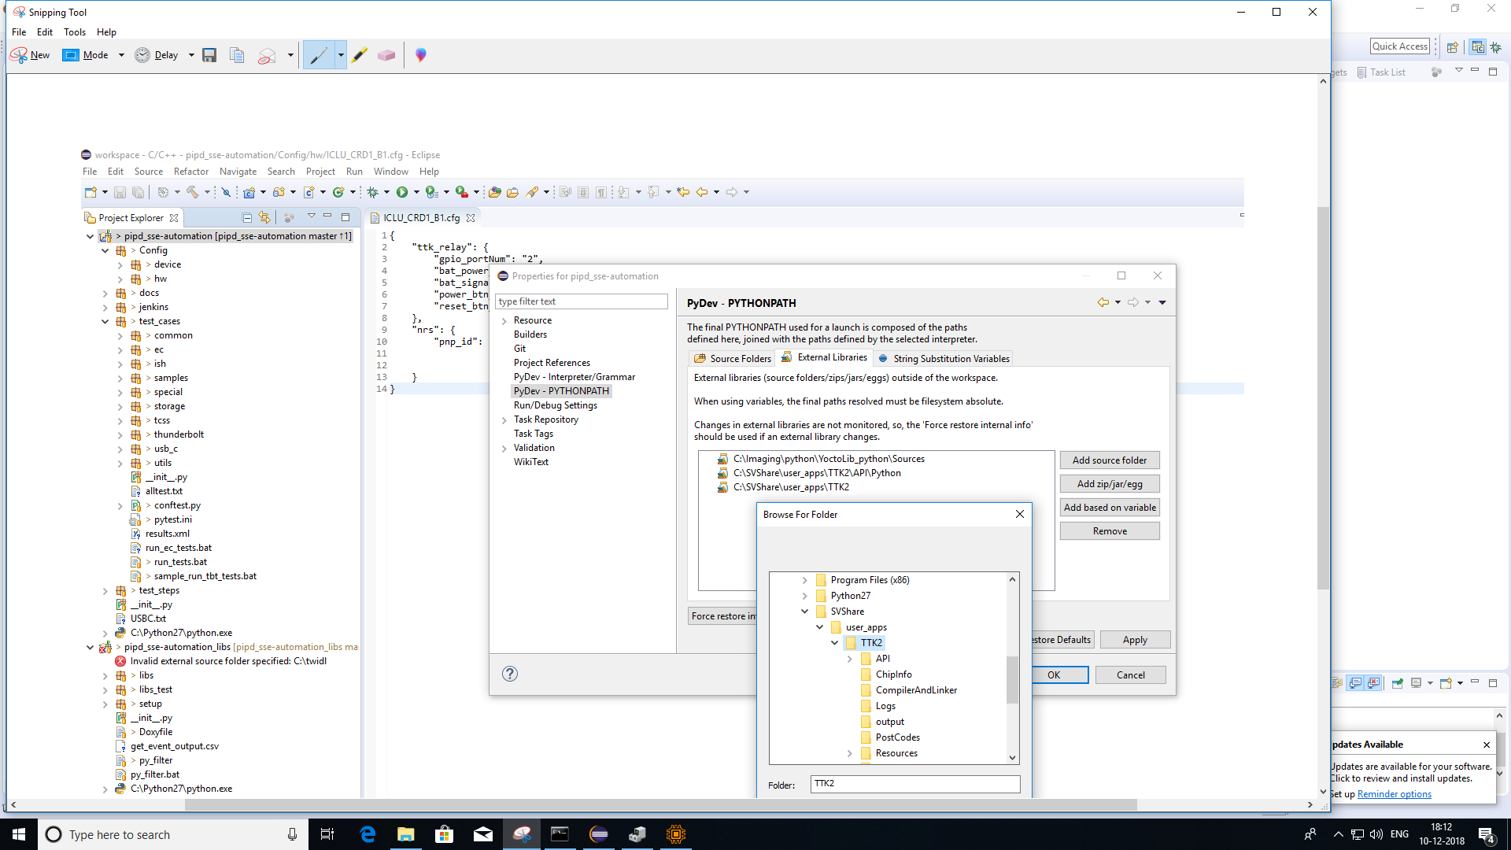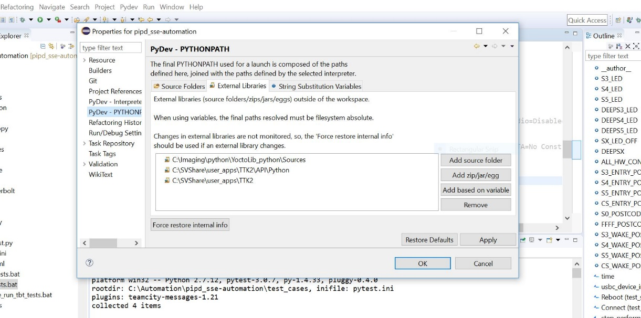

* + How to Setup Pytest
    - Open Eclipse
    - Go to Windows->Preferences->PyDev->PyUnit.
    - Set "Test Runner" to "Py.test runner".
    - Clear the parameter all parameters in dialog box.

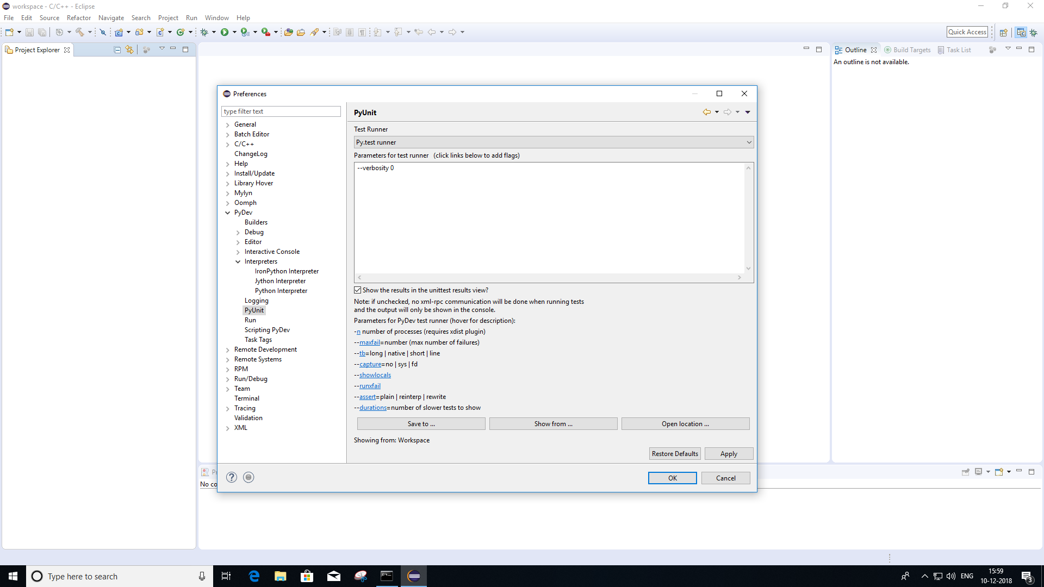

# **NRS Board Setup:**

* + - Install USB 2 Serial driver on HOST
    - Go to device manager and find out the device ID as shown below for SUT config file.

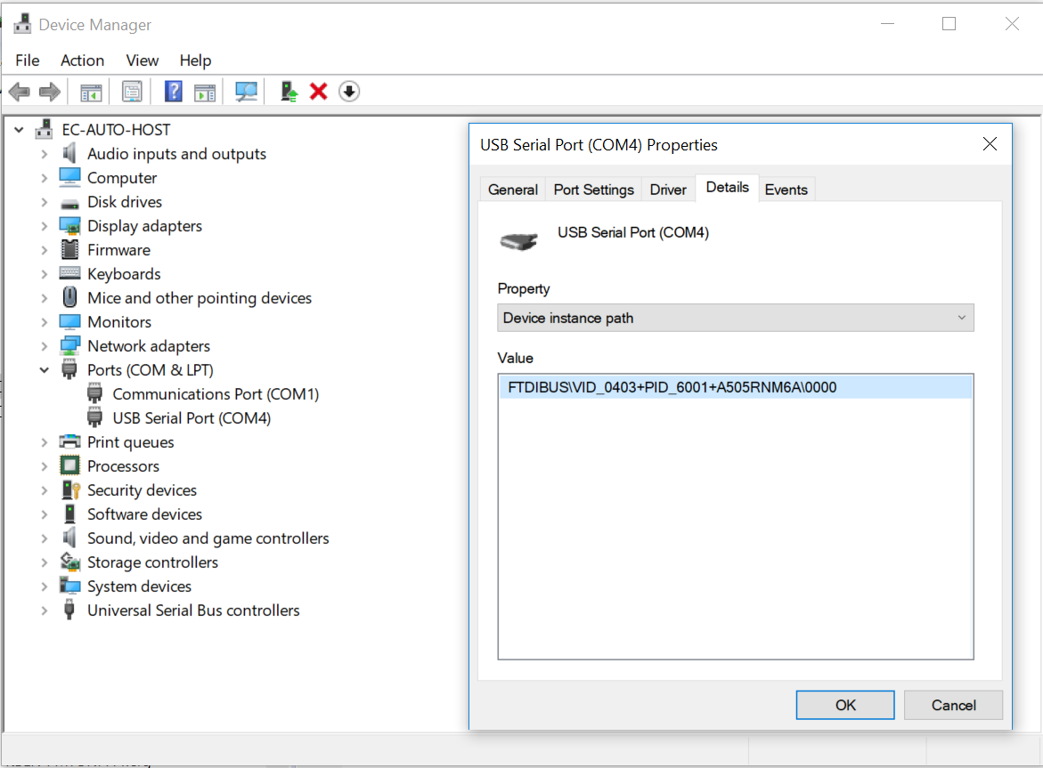

# **HW (DUT) Config file for project:**

* + - Create a .cfg file with the name of the SUT and keep it under C:\automation\pipd_sse-automation\Config\hw folder
    - Have the TTK and NRS board details in that as shown below.

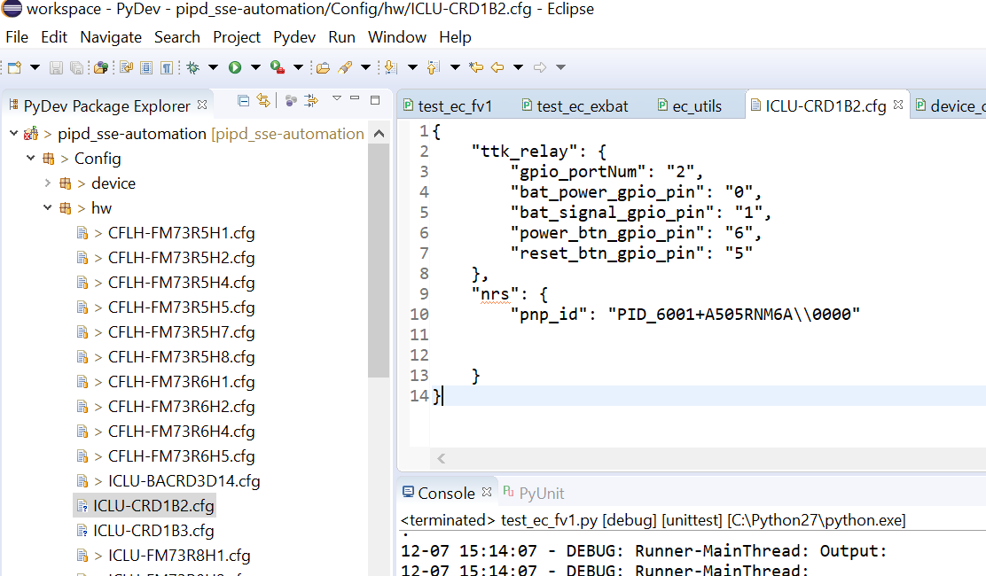

# **Device Config file**

TO DO

# **How to Run Test**

* + - From Eclipse, select Run -> Run Configuration and a window will pop up.
    - Select "python unittest" on the left side of the window, right click and select new

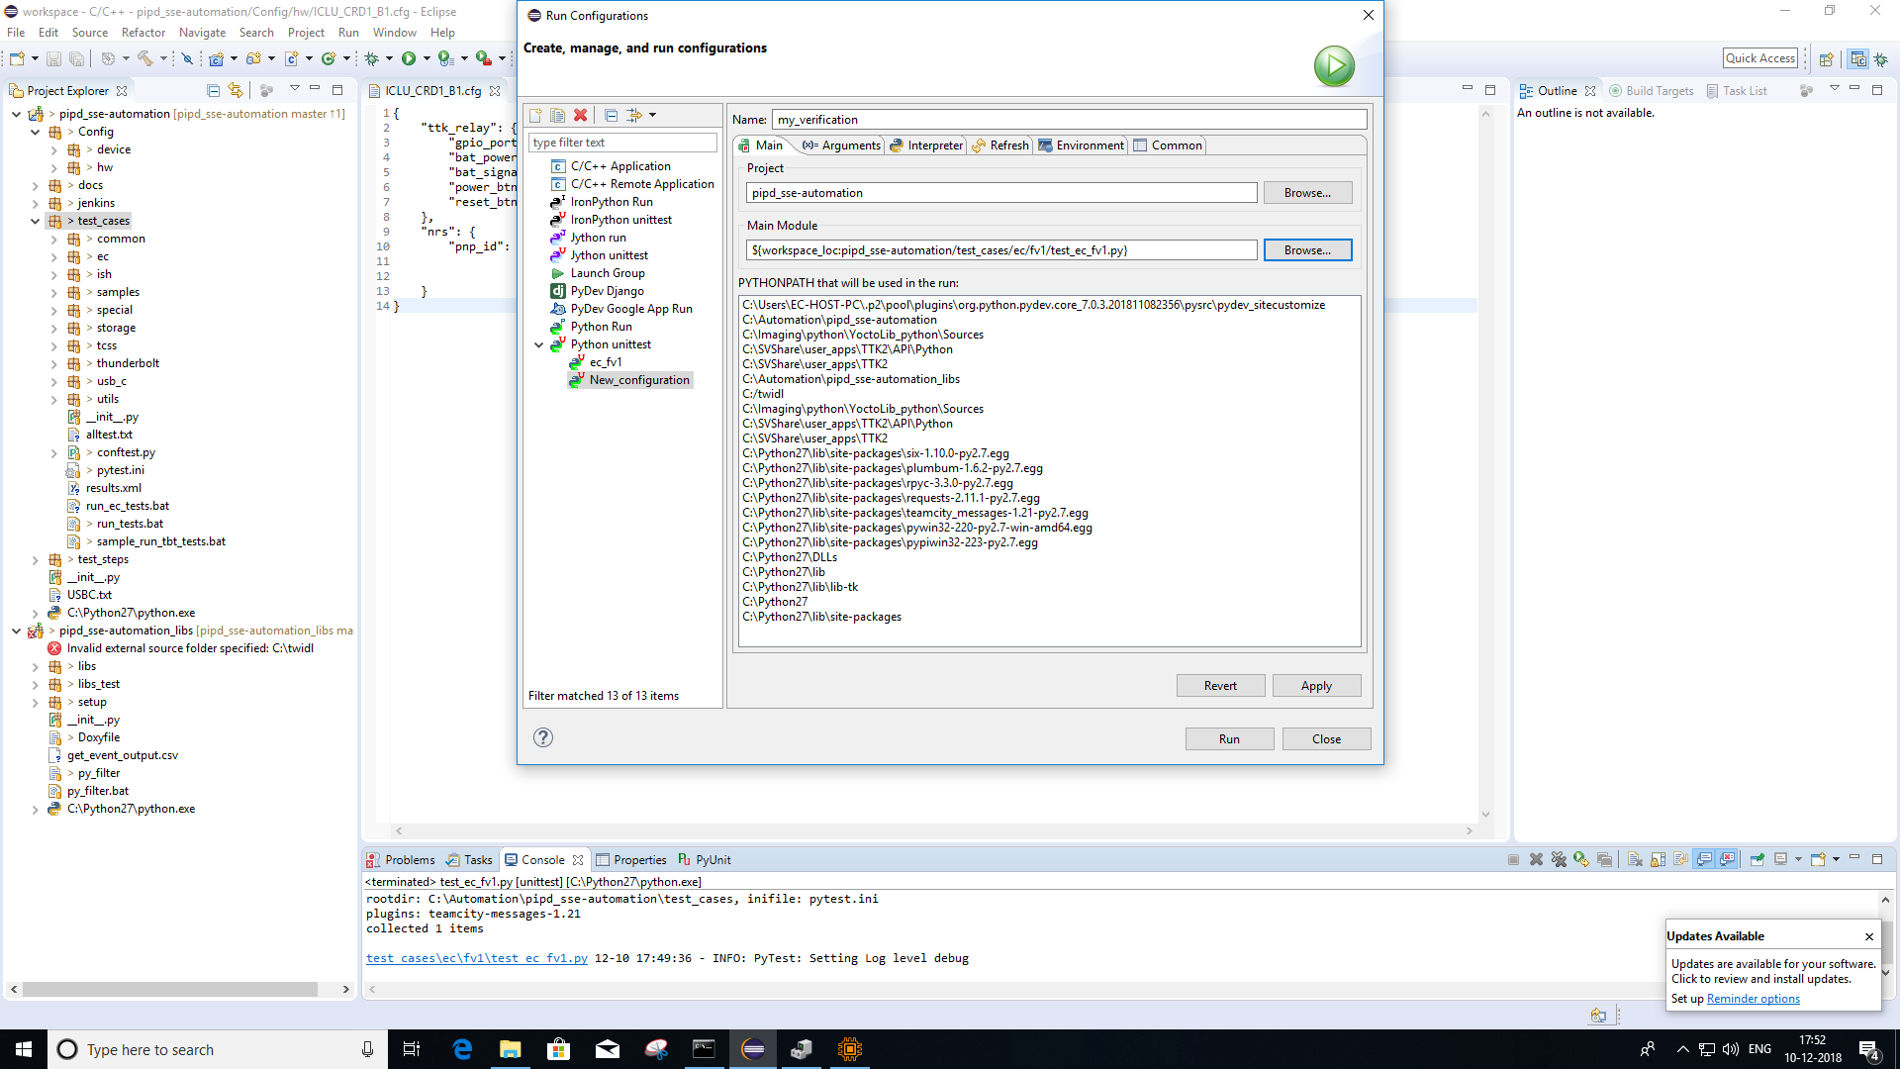

* + Settings for each tab on the right side of the window:
    - Name : my_verification
    - Project = pipd_sse-automation
    - Main Module: Select python script that contains test case.
  + Arguments
    - Select "Override pyunit preferences" and set to:
    - --capture=no --log_level=debug (if all tests to run)
    - --capture=no --log_level=debug -k <test name> (This is the name of the function to run. If this is blank, it will run all tests in the file)
    - If log level is info, it will not print debug logs.
  + Select Interpreter as default.
  + Environment
    - AUTOMATION_REPO_DIR = <path to lib> Ex: C:\automation\pipd_sse-automation_libs
    - AUTOMATION_STEP_REPO_DIR = <path to test steps> Ex: C:\automation\pipd_sse-automation
    - DUT_NAME = <Dut hostname> Ex: KBLR-FM73R5H5
    - NO_PROXY = * (this is an asterisk)

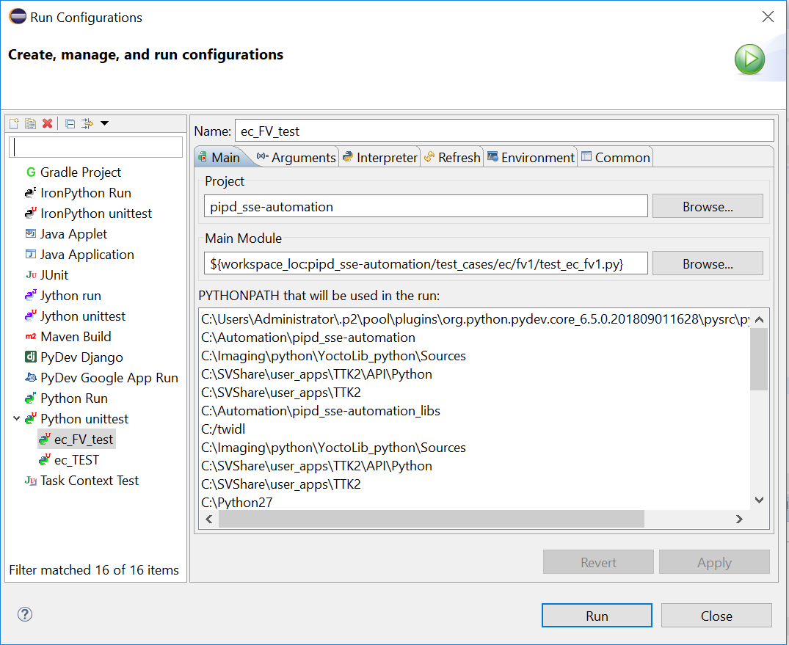 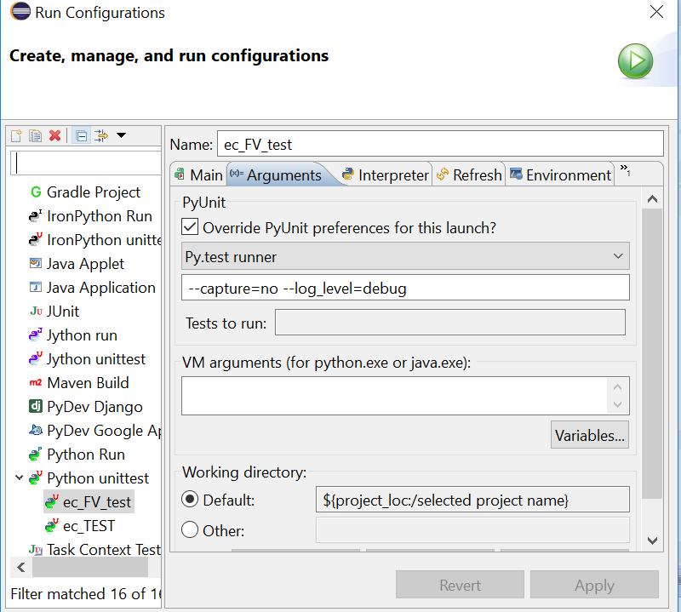

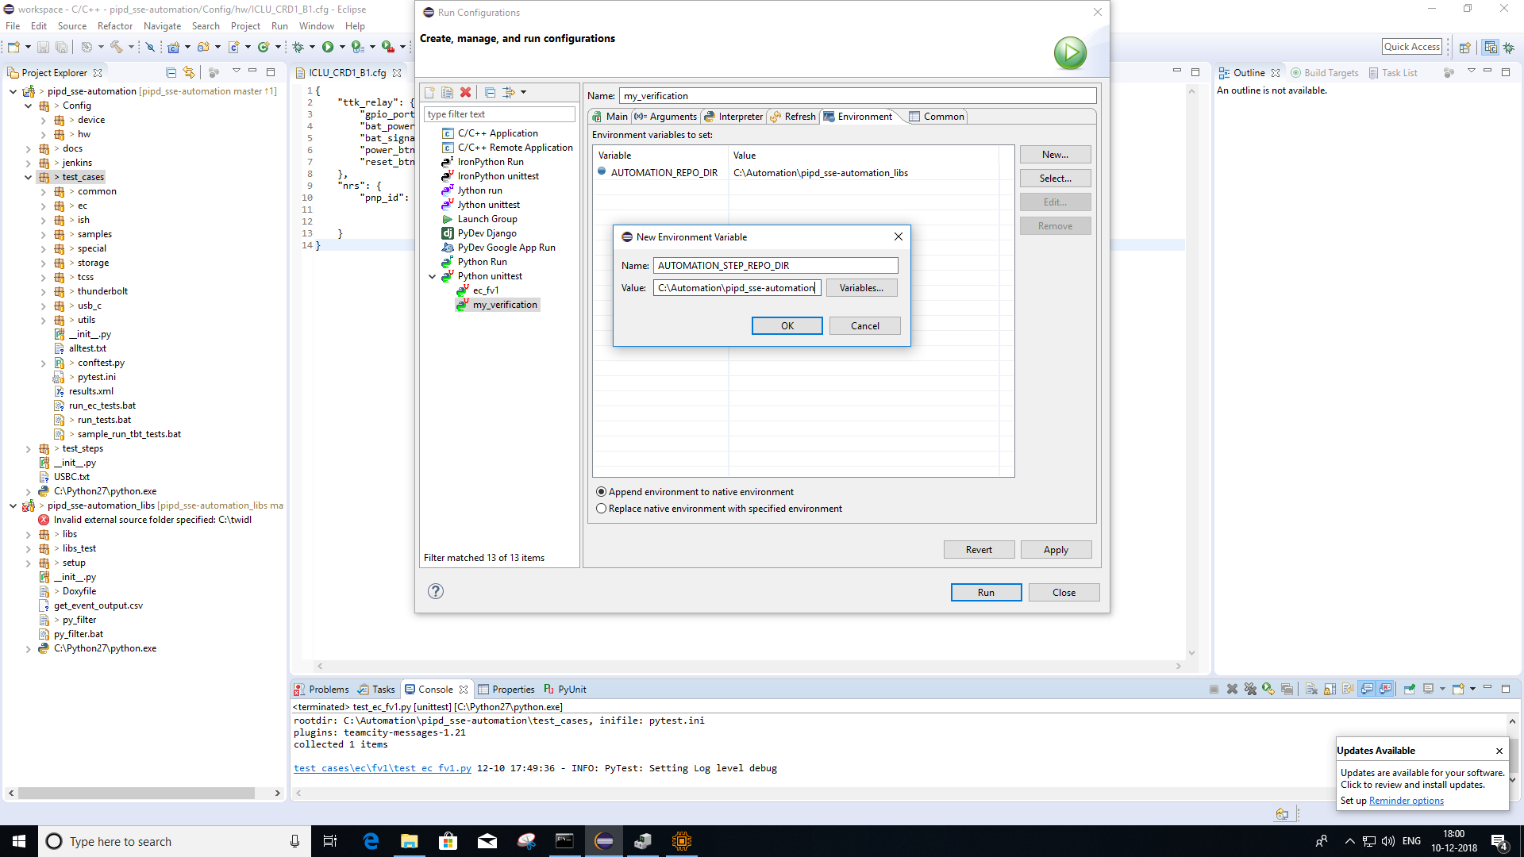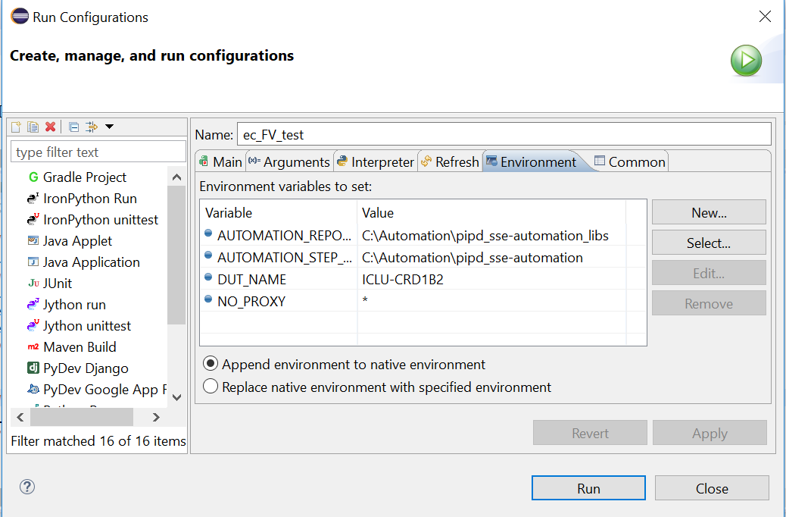

# **Run a Single Test**

* The following instructions show how a single test case is run.
* Open the file pipd_sse-automation/test_cases/run_tests.bat
* The following lines can be modified to run a test case:
  + set TEST_CASE=
  + set TEST_CATEGORY=
  + REM %PYTEST% -s --junitxml=%RESULTS_XML% -k %TEST_CASE% %AUTOMATION_STEP_REPO_DIR%\test_cases\%TEST_CATEGORY%

Set “TEST_CASE” to the test case to be executed.

Set “TEST_CATEGORY” to the category in the pipd_sse-automation/test_cases directory that contains the test case.

* Open a command window in the directory pipd_sse-automation/test_cases and run the batch file run_tests.bat.

# **Modules to be used for write a new test scripts**

1. Initial Settings Operations

perform_pretest_operation()

1. Update bios
2. Verify postcode
3. Verify led status
4. Check device manager
5. Add key to registry
6. Verify Battery charging
7. Verify USB enumeration
8. Verify data transfer
9. Put system to Sx using power button press
   1. With verifying LED
   2. With verifying post code

# **Troubleshoot**

1. WINRM Service ERROR

07-26 03:45:16 - DEBUG: WindowsDeviceBase-MainThread: Add IPaddress to list of trusted devices

07-26 03:45:16 - DEBUG: Runner-MainThread: set-item wsman:\localhost\Client\TrustedHosts -value ICLU-BACRD3D14 -Force

.

07-26 03:45:19 - DEBUG: Runner-MainThread: Output:

07-26 03:45:19 - DEBUG: Runner-MainThread:

07-26 03:45:19 - DEBUG: Runner-MainThread: set-item : The client cannot connect to the destination specified in the request. Verify that the service on the destination is running and is accepting requests. Consult the logs and documentation for the WS-Management service running on the destination, most commonly IIS or WinRM. If the destination is the WinRM service, run the following command on the destination to analyze and configure the WinRM service: "winrm quickconfig".

At line:1 char:1

* Check if the winrm service is running or stopped
  + At the PowerShell prompt, you can verify that the WinRM service is running using the following command: **get-service winrm** The value of the Status property in the output should be “Running”.
  + To configure Windows PowerShell for remoting, type the following command:   
    **Enable-PSRemoting –force**
  + **winrm s winrm/config/client '@{TrustedHosts="RemoteComputer"}‘**
    - **winrm s winrm/config/client '@{TrustedHosts=“ICL-BACCRD3D14"}'**

1. Import clr Error

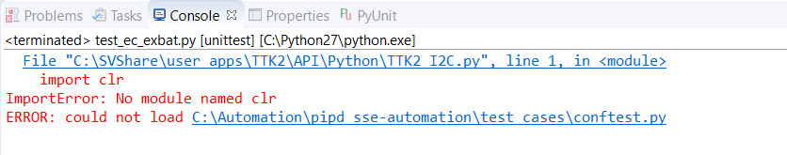

TTK python packages are not installed. Install those packages and restart the PC.

1. TTK Error

